**Baoling participated in the 2025 Annual Conference of the Sports Medicine Specialized Committee of the Yangtze River Delta Hospital Alliance and the Symposium of the Upper Limb Group of Sports Medicine in Jiangsu Province**

From June 13 to 14,2025, the '2025 Yangtze River Delta Hospital Alliance Sports Medicine Specialty Committee Annual Meeting and Jiangsu Province Sports Medicine Upper Limb Group Seminar,' co-hosted by the Sports Medicine Department of Jiangsu Provincial People's Hospital and Jiangsu Northern People's Hospital, was successfully held in Yangzhou. The conference brought together renowned sports medicine experts from Jiangsu, Zhejiang, Shanghai, Anhui, and Beijing to share and discuss the latest advancements, technologies, and concepts in sports medicine and related fields. The offline venue and surgeries were live-streamed nationwide, attracting a large number of orthopedic and sports medicine doctors online, with over 2,500 participants joining the online session. Shanghai Baoling Medical Devices Co., Ltd., represented by its two major rehabilitation brands, Breg and Aspen, as industry innovators, were invited to exhibit, showcasing multiple innovative orthopedic brace solutions and discussing the cutting edge of technology with the industry.

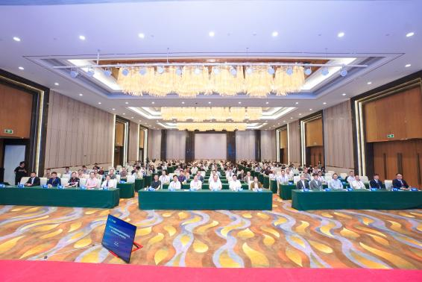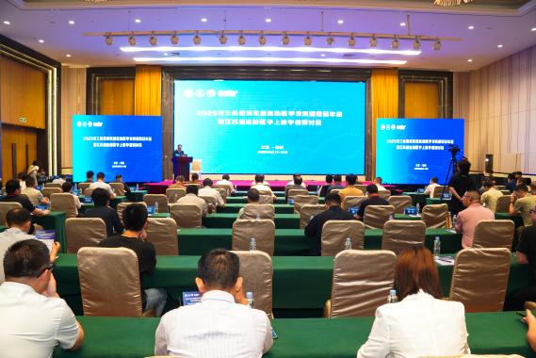

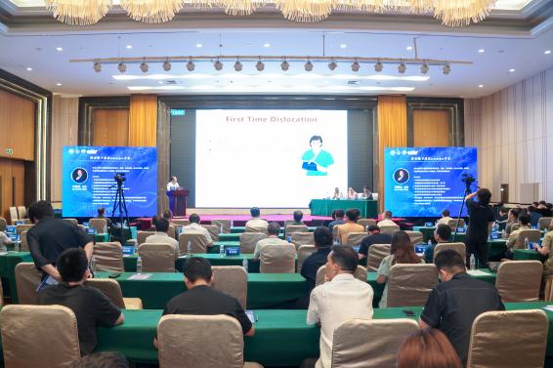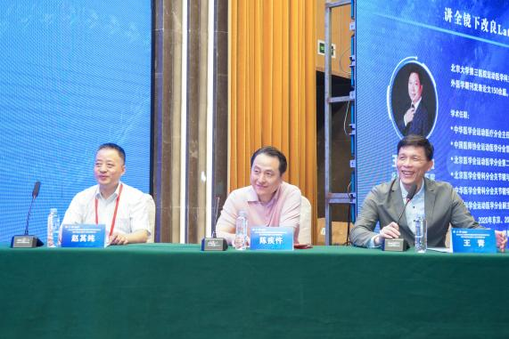

During the exhibition, Bao Ling Medical showcased a comprehensive range of innovative products from its limb joint orthosis brand Breg. These include the Genesis® walking boot, Slingshot3® shoulder abduction brace, T-Scope premier® knee, elbow, and hip joint fixation braces, AXIOM®-DElite dynamic ligament braces, and FUSION OA and DUO® conservative treatment braces for osteoarthritis. Additionally, the company highlighted three key series of mainstream products: the Vista® Colla postoperative cervical collar, Horizon® lumbar support for lower back pain, and Summit® postoperative lumbar support for spine conditions. The exhibition attracted numerous academic experts in sports medicine to visit the Bao Ling Medical booth. They engaged in active discussions with our staff about the current clinical use of orthosis products and the unmet clinical needs. The experts also gave high praise to the Breg & Aspen sports medicine product lines and expressed strong expectations for their future development.

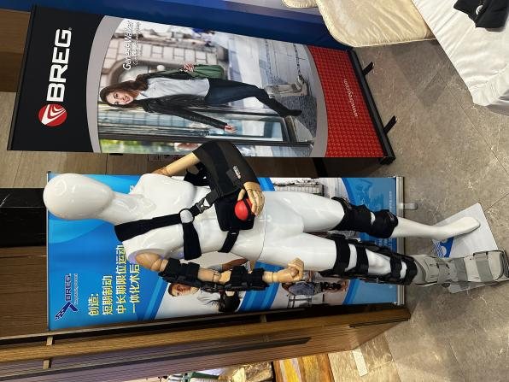

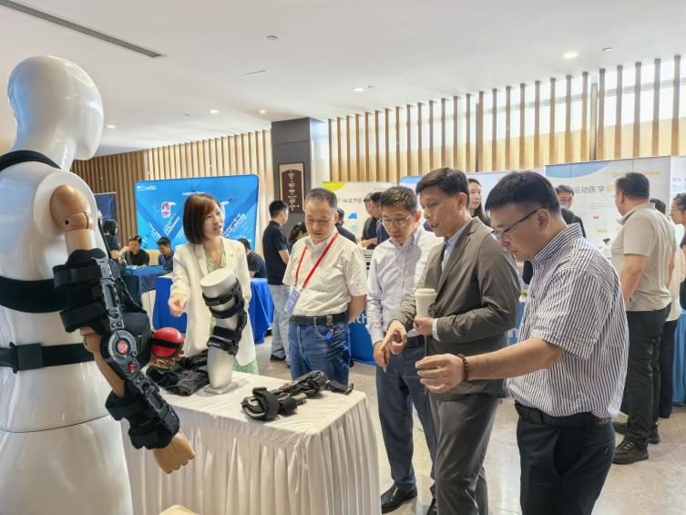

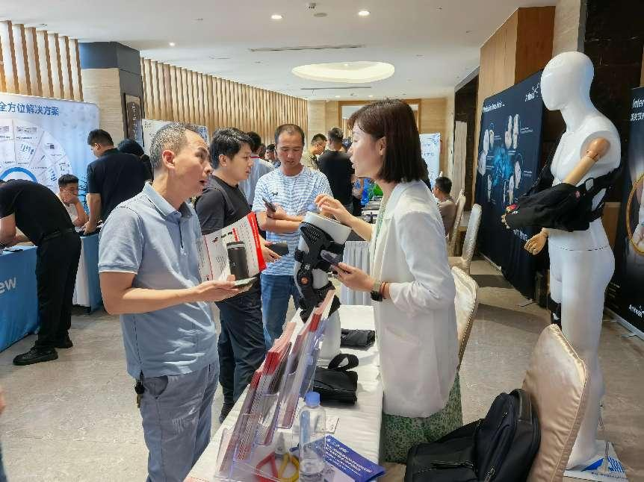 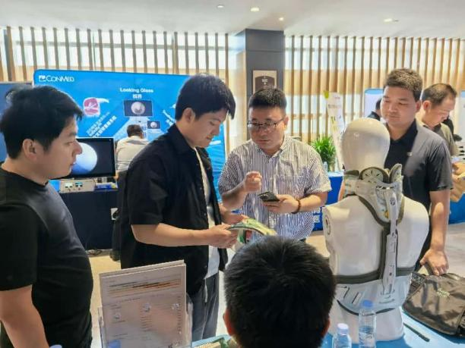

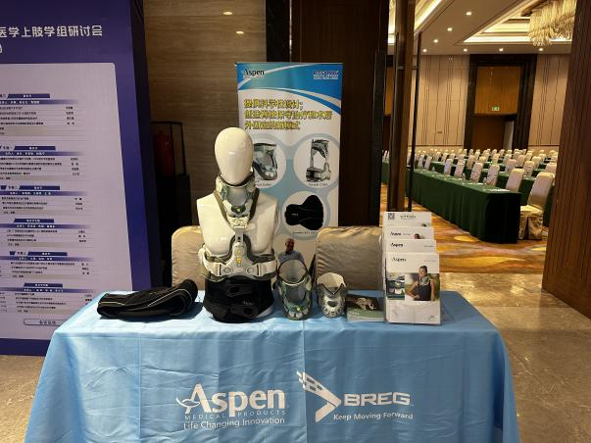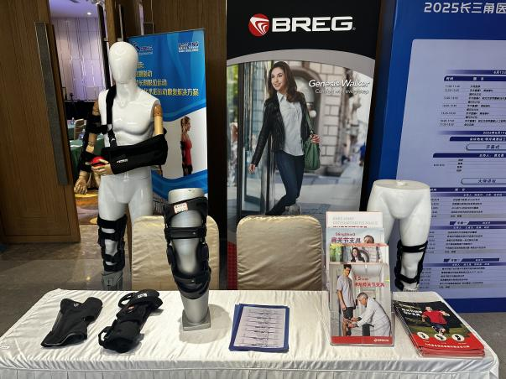

Through this conference, Shanghai Baoling Medical has gained a lot. We will further link clinical needs with technological innovation, continue to focus on professional and detailed work in the future, and work with industry partners to promote the development of orthopedic rehabilitation technology, so as to provide doctors and patients with more accurate solutions.