# Baolin Medical Exhibition FIMS Cooperation Center headquarters and Hainan Guoping Sports Medicine and Health Research Institute launch conference

From December 1 to 4, Baolin Medical, together with Breg & Aspen international famous brand sports medicine support, participated in the launch conference of the International Sports Medicine Federation (FIMS) Cooperation Center headquarters and Hainan Guoping Sports Medicine and Health Research Institute held in Sanya, Hainan. The conference attracted well-known sports medicine experts at home and abroad, such as Director Zhang Xia, president of International Federation of Sports Medicine, representative of General Administration of Sport, and Professor Li Guoping, representative of the headquarters of FIMS Cooperation Center.

During the exhibition, Baolin Medical demonstrated in detail the three star products: Vista ® Colla postoperative neck support, Horizon® lower back pain for lumbar support, Summit® postoperative lumbar support, and Bregs innovative products: Genesis® walking boot, T-Scope premier® knee and elbow limited fixed support, Slingshot3® abductor shoulder strap, DUO ® conservative treatment support for osteoarthritis, Axiom-D ® dynamic ligament injury conservative treatment support, etc.

Many academic experts in the field of sports medicine came to the Baolin medical booth and gave a high evaluation of the Breg & Aspen sports medicine product line.

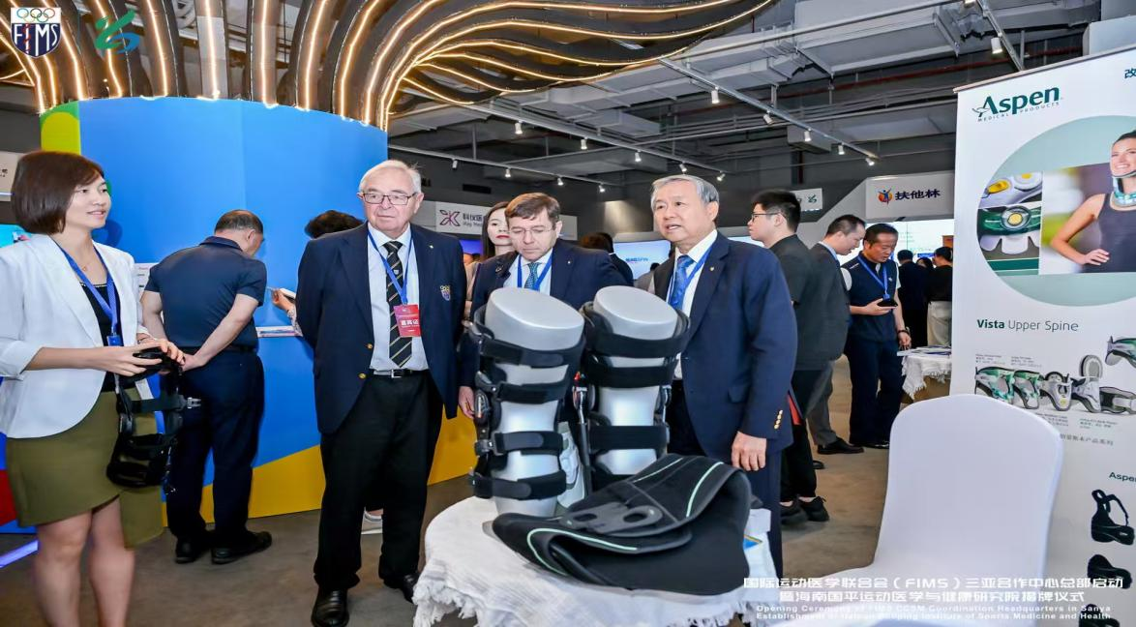

1

