Aspen Taiwan general distributor visited Bao Ling Medical

At the invitation of Aspen USA Headquarters, Ms. Amy Lin, Head of General Distribution in Taiwan, China, visited Aspen China General distributor Shanghai Baoling Medical Equipment Co., LTD. on March 01, 2024, and gave training to their sales team on interactive marketing experience. This paper discusses the tactical key points of the future academic promotion strategy transformation of Aspen product line of Baoling Medical.

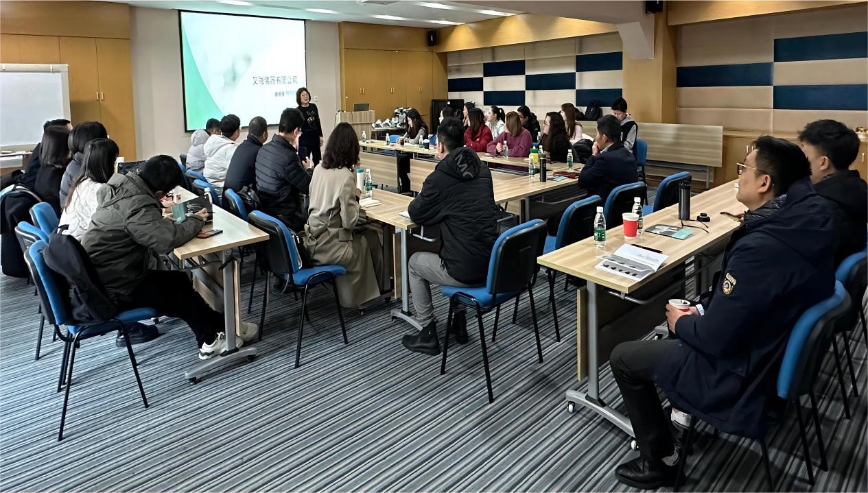

Ms. Amy Lin giving a lecture