

SlingShot® 3 Shoulder Brace Quick Application

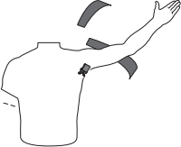
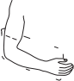
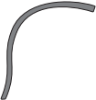
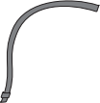
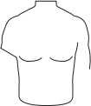

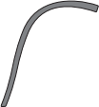
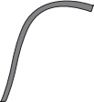
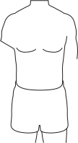
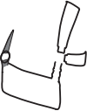

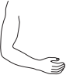
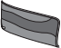

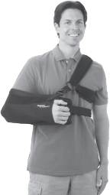
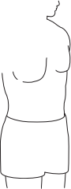

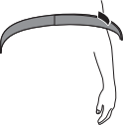
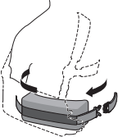

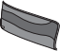




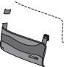


1
J
2
3
Place injured arm in sling.
Put opposite arm through harness
Separate shoulder harness and placestrap over shoulder. Attach with buckle.
and attach with buckle.

OR


Make adjustments to fit
patient;
tighten
posterior slide and
shoulderstraps as
necessary.
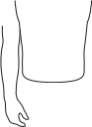

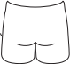
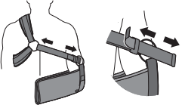

Place pillow(s) under
strap.
waist
sling and attach

Scan QR code for Breg’s SlingShot 3 instructional video.
breg.com/SS3

OVER

SlingShot® 3 Shoulder Brace
Application Tips

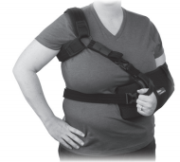 |  | 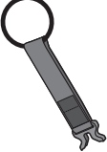  (fig. a) | 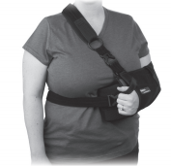
  Tip | For large chest: add extension  strap accessory (fig. a) to shoulder  harness. This will improve fit for  added comfort. |  |   Tip |  | For large chest: simply remove the underarm strap from the harness  for traditional sling fit.
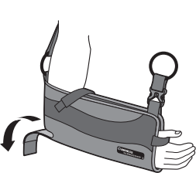 |  |  |  | 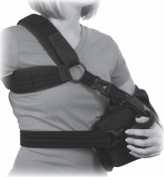  For petite body types: adjust the  shoulderstraps as needed for a  snug fit. Secure back strap and trim excess length.
  Tip | For individual fit: adjust the elbow  relief “door” to tightensling or  release the elbow relief “door” to |  |   Tip
relieve olecrenon pressure.

2885 Loker Ave. East, Carlsbad, CA 92010
Ph: 800-321-0607 Fax: 800-FAX-BREG (329-2734)
800-897-BREG (2734) 800-959-BREG (2734)
www.b reg. com
© 2012 Breg, Inc. Breg is an Orthofix company. All rights reserved. AW-1.96067 Rev B 0312
SlingShot is a registerd trademark of Breg, Inc.

